Geometry: Unit 7, Lesson 3
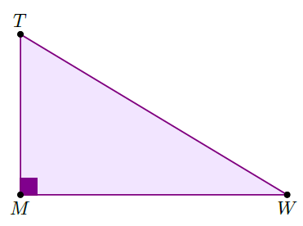
- Right triangle $∆TMW$ is shown. What is the ratio of the tangent of $∠W$?

$$\frac{TM}{MW}$$

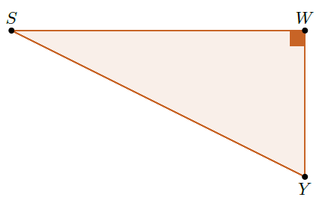
- Right triangle $∆SWY$ is shown. What is the sine of $∠S$?

$$\frac{WY}{SY}$$

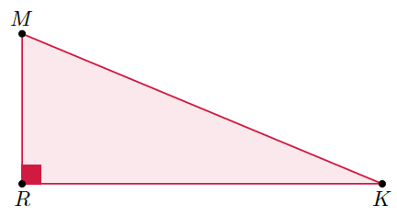
- Right triangle $∆MRK$ is shown where $MR=5$, $RK=12$, and $MK=13$. What is the tangent ratio of $∠K$?

$$\frac{5}{12}$$

